Chat bot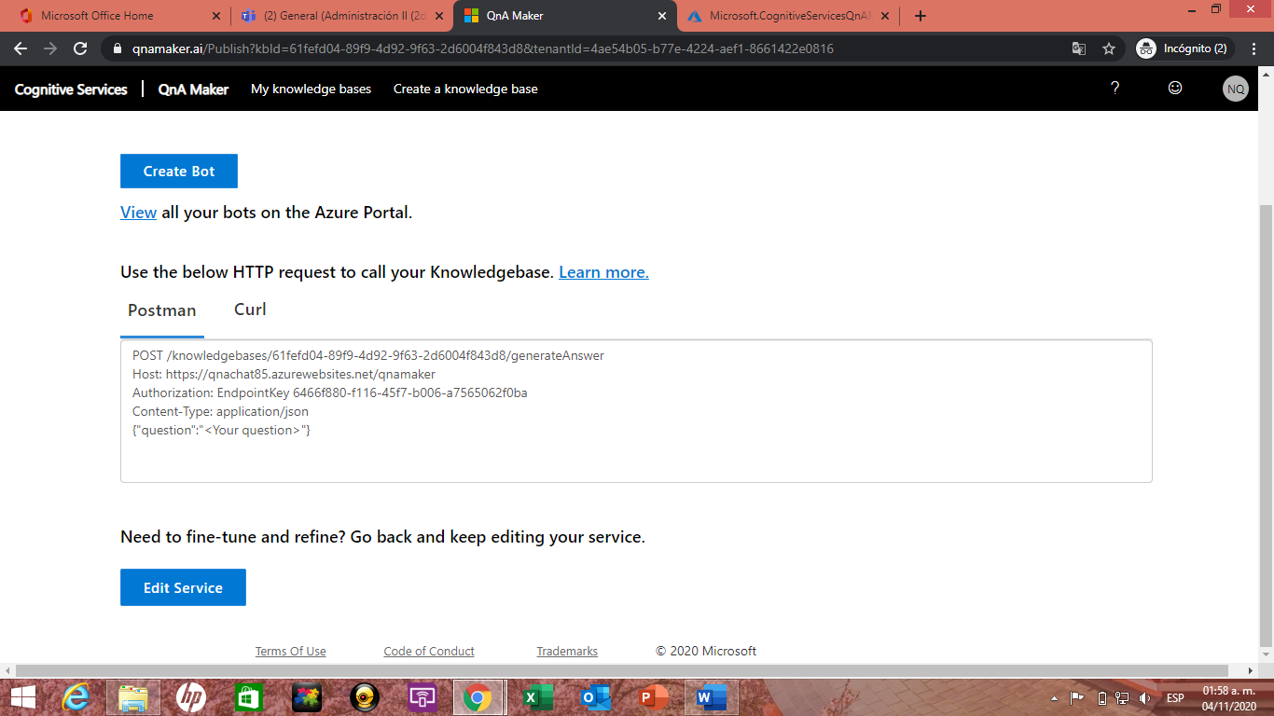

POST /knowledgebases/61fefd04-89f9-4d92-9f63-2d6004f843d8/generateAnswer

Host: https://qnachat85.azurewebsites.net/qnamaker

Authorization: EndpointKey 6466f880-f116-45f7-b006-a7565062f0ba

Content-Type: application/json

{"question":"<Your question>"}

Curl

curl -X POST https://qnachat85.azurewebsites.net/qnamaker/knowledgebases/61fefd04-89f9-4d92-9f63-2d6004f843d8/generateAnswer -H "Authorization: EndpointKey 6466f880-f116-45f7-b006-a7565062f0ba" -H "Content-type: application/json" -d "{'question':'<Your question>'}"